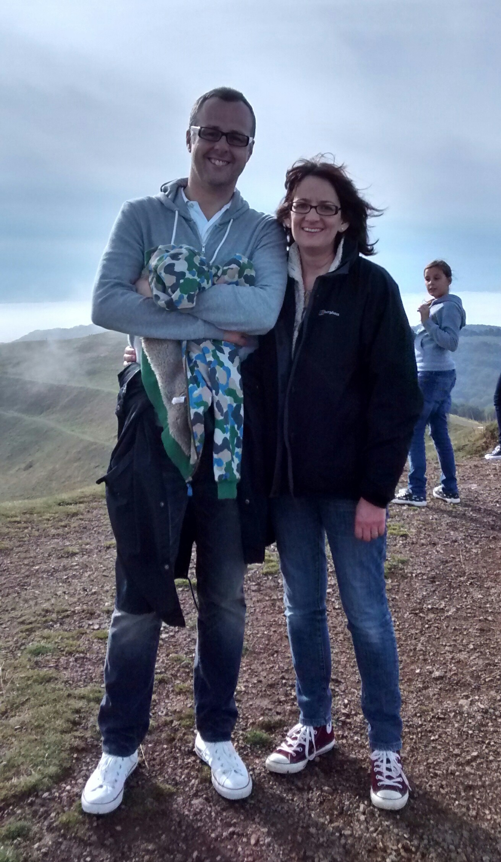

**For more information please contact our social worker Sophie Gatsby**

**Adoption a Family Placement Team**

**Email: s.gats@adoptionsouth.org.uk Telephone: 0206 11 31233**

* We would like to adopt two children of either gender, up to the age of 8.
* Ruth is a school SENCO and

Ben a teacher.

* We have both have an understanding of developmental trauma and therapeutic parenting.
* We would welcome children who have some moderate emotional and behavioural difficulties and developmental uncertainty.

**Ruth**

**& Ben**

s/agency contact details

**Hello**

We are Ruth aged 40 and Ben aged 42.

We have been fully committed to each other for 10 years and have been

living together for 7. We firmly believe that all children deserve a warm and loving home and are open to respectfully parenting children from a different ethnicity or background to our own. We are both White British, none practicing Christians.

We live in a small village in Buckinghamshire where we enjoy being part of a close community. We enjoy being actively involved in our 9 nephews and nieces and have strong relationships with our family and friends. All have a good understanding of our adoption plans and have promised us their support in a number of different ways. We are members of a local adoption support group.

Our cottage, which we have recently modernised, has plenty of space for our new family, both inside and out. We live close to local schools and playgrounds.

Ruth will take adoption leave from her job as a secondary school SENCO for up to a year. Ben will continue to work as a Geography teacher where he has worked for five years.

We are both active people and enjoy spending time outdoors walking and camping. Ben has a passion for football and is a big Spurs supporter. Ruth is an enthusiastic gardener and has a number of hobbies ranging from beginners piano and experimental cookery. Ruth helps run the local Brownie Guides group.

**We look forward to hearing from you soon**